Lab Settings
1. Log in to the Security Onion VM using username “pigpen” and the password “redbaron.”
Use YARA to Find Malware
Scenario: During your review of ICS related RSS feeds, blogs, and mailing lists, you notice an Alert for
malware targeting the chemical sector. The alert states the malware was first noticed on the laptop of
an engineer who had just attended a Petroleum and Chemical Industry Conference at the Disney World
Resort in Orlando, Florida. You know three of your company’s engineers attended this conference. The
Alert provides the following YARA rule to test for the SnowWhite malware.
rule SnowWhite {
meta:
description = "Detect variants of the SnowWhite malware"
strings:
$key = { 7b 4f 53 ec 54 82 c8 6a 62 87 fe 53 de 1b 9f dd 0c d6
57 10 0e 00 f3 c7 dc 35 a9 bb 86 6d c9 34 }
condition:
all of them
}
Use the YARA rule to find any instances of the SnowWhite malware on your machine. Open a terminal
window and type the following command to run the YARA search.
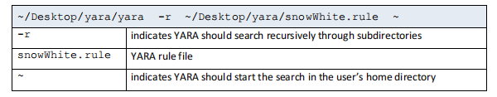

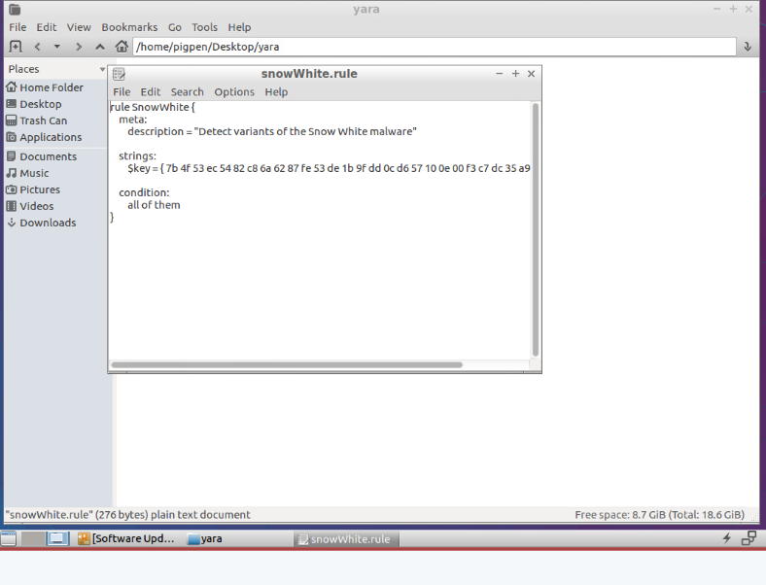
- What files did you find and where did you find the files?
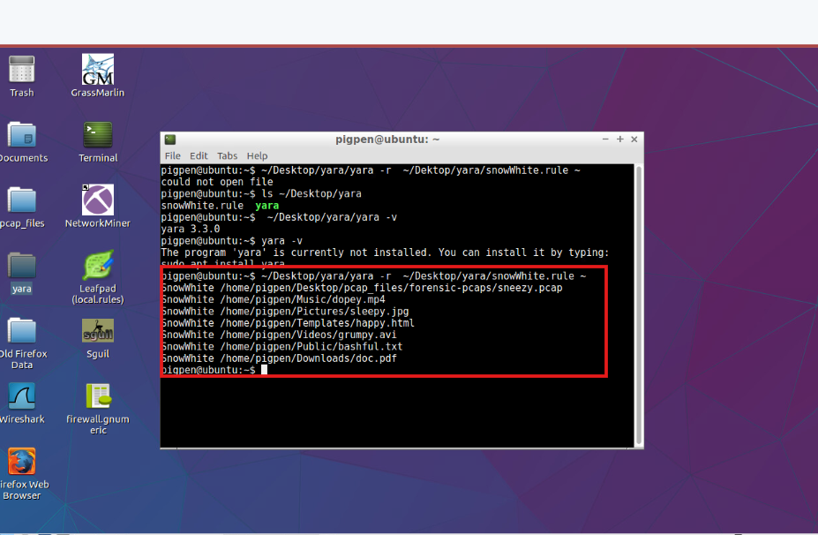
3. The malware is unknown to you. What external agency could you call for assistance?
ABŞ üçün bu ən məşhur agentlik NCCIC (National Cybersecurity and Communications Integration Center) sayılır.Əgər şirkət xaricində bir agentlik çağırmaq istəsən, “CERT” (Computer Emergency Response Team) və ya “US-CERT” də uyğun olar

Ann Skips Bail
After being released on bail, Ann Dercover disappears. Fortunately, investigators were carefully
monitoring her network activity before she skipped town.
“We believe Ann may have communicated with her cohort, Mr. X, before she left,” says the police chief.
“The packet capture may contain clues to her whereabouts.”
You are the forensic investigator. Your mission is to figure out what Ann emailed, where she went, and
recover evidence.
NOTE: You will use NetworkMiner for this Exercise
1. Open NetworkMiner. Select "File -> Open". Select the file " Desktop/pcap_files/forensics
pcaps/netforensics_evidence02.pcap" and click the "Open" button.
a. How many email messages are in this pcap?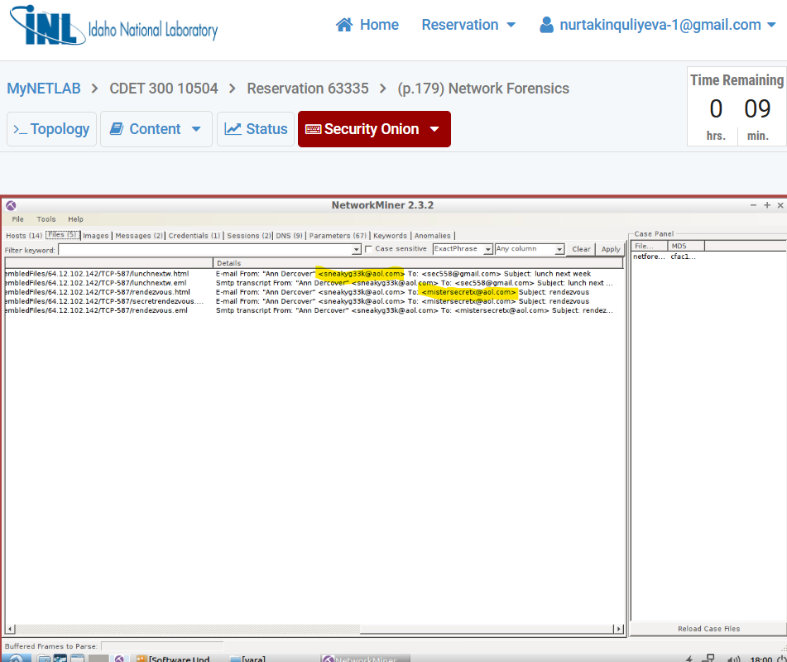
b. How many files are in this pcap?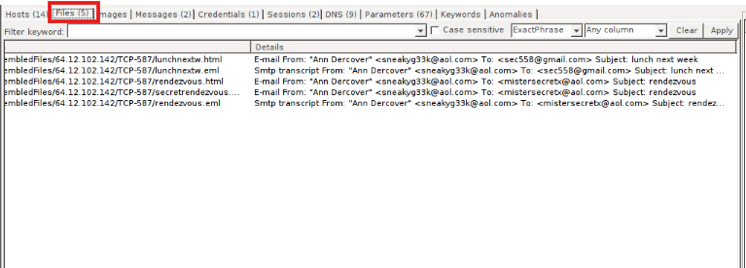
c. How many hosts are involved? 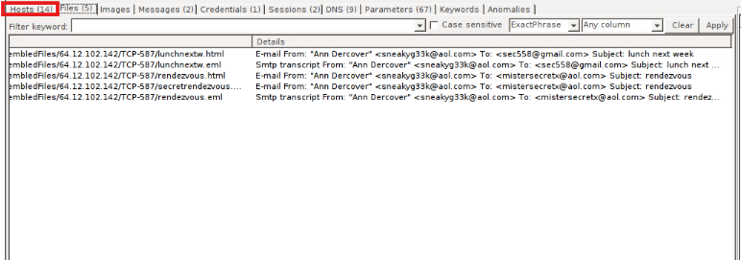d. What are the Operating systems used by the hosts? You can summarize by OS.
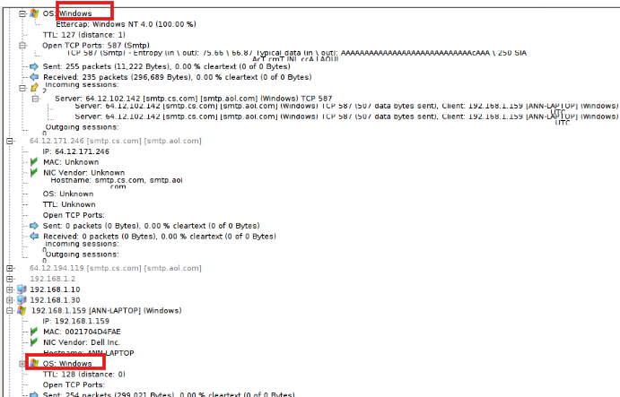2. What is Ann’s email address? 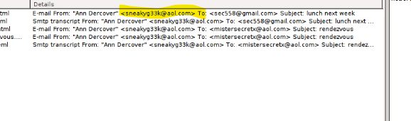
3. What is Ann’s cohort’s email address? (hint: second email) 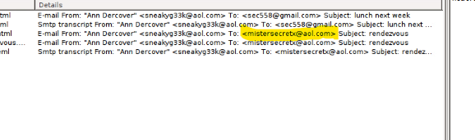
4. What two items did Ann tell her cohort to bring? 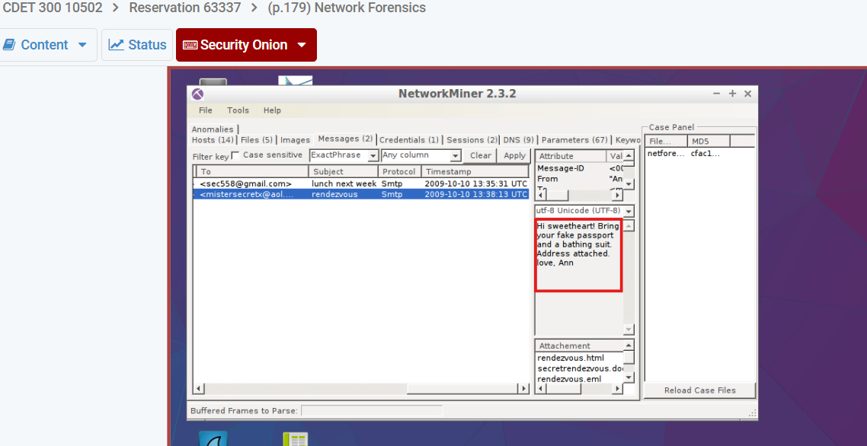
5. What is the NAME of the attachment Ann sent to her cohort? 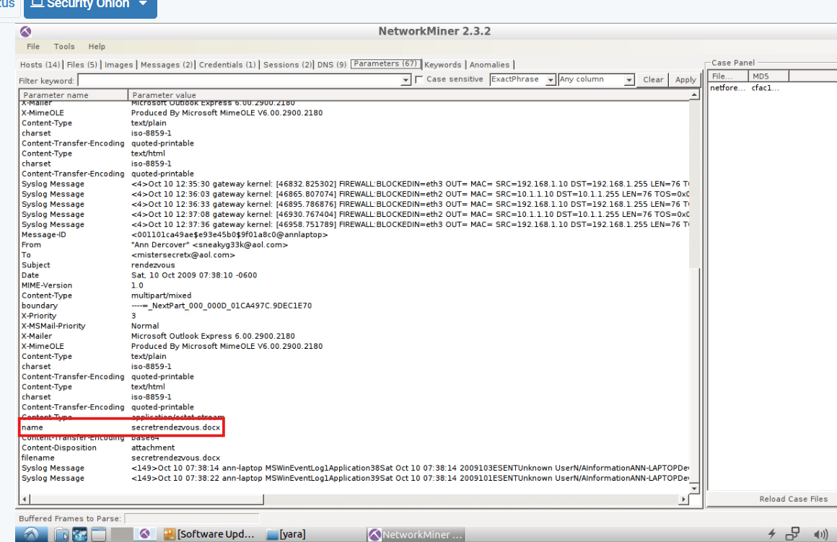

Extra Credit
1. What is Ann’s email password?
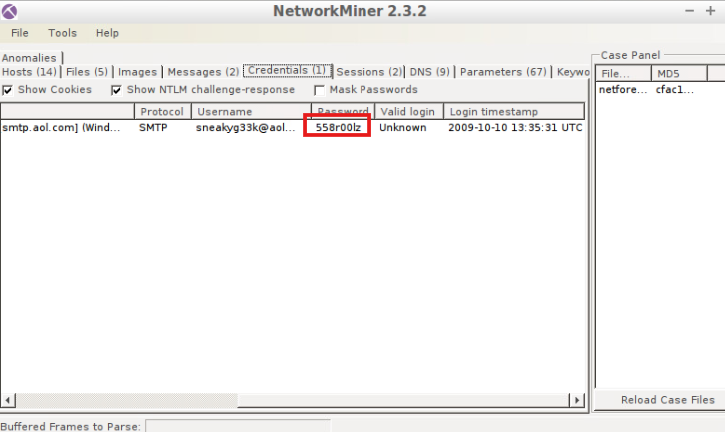
2. In what CITY and COUNTRY is their rendezvous point? 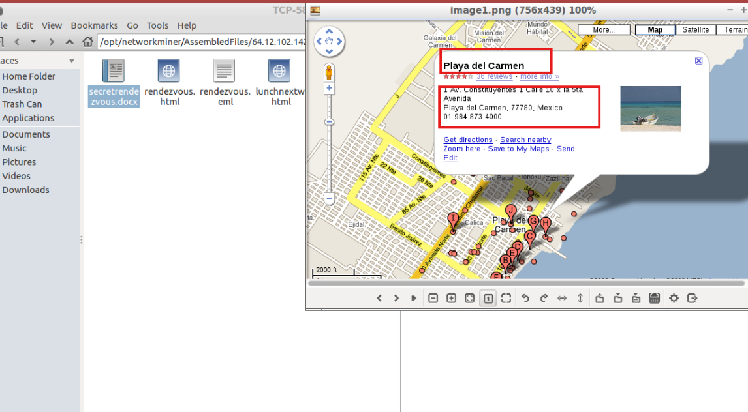

Exploit Demo
NetworkMiner will append pcap information to existing information. To clear the information from the
previous exercise, select “Tools -> Clear GUI” from the NetworkMiner menu.
1. Open NetworkMiner. Select "File -> Open". Select the file
"Desktop/pcap_files/ExploitDemo/ExploitDemo.pcap" and click the "Open" button.
- How many hosts are involved?
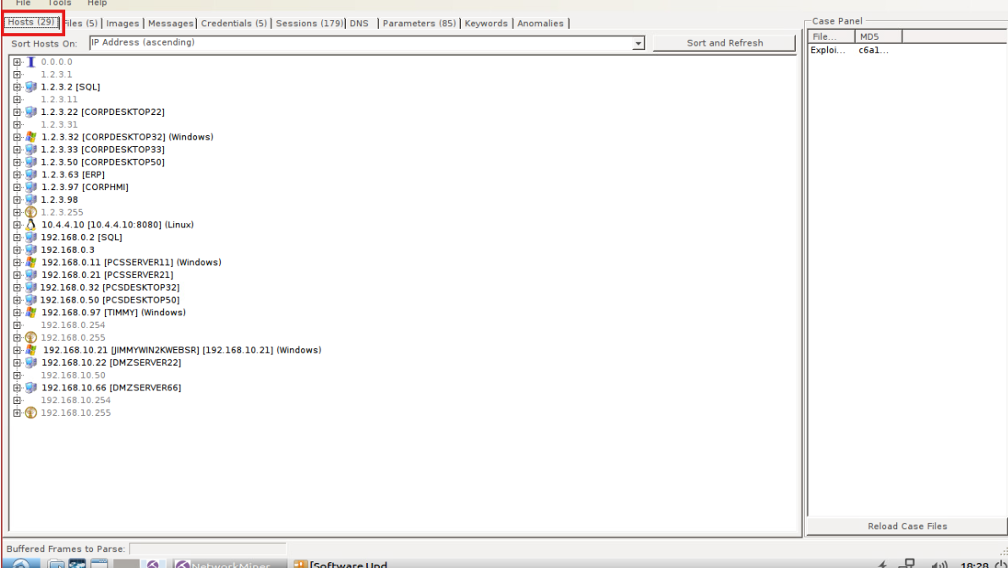
b. What external host do you see? (Ignore any 224.0.0.x and IPV6 traffic.)
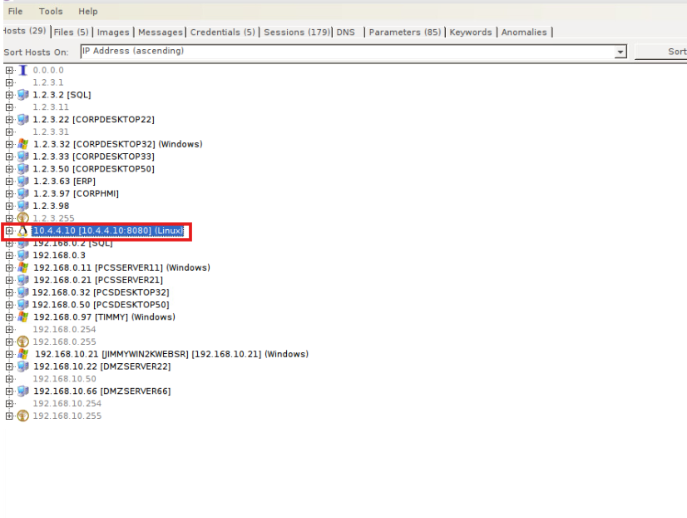
c. What are the operating systems used?
Linux and Windows
d. How many files are in this pcap? What are the file names?
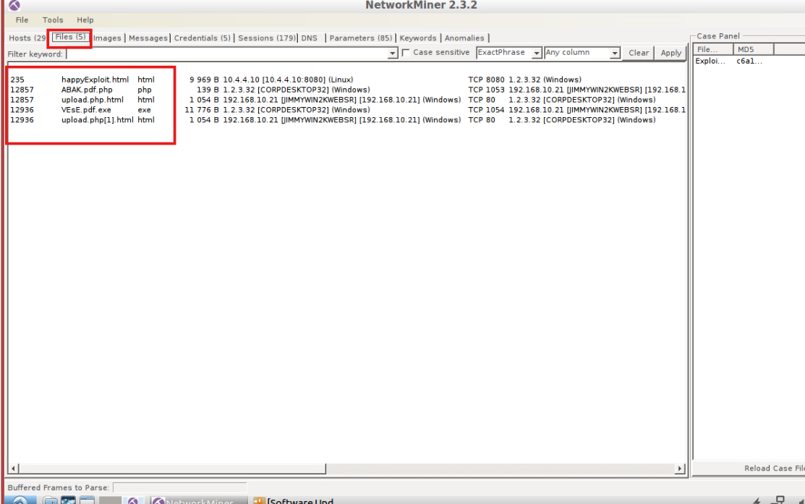

2. Right-click on the happyExploit.html file and select Open file. A blank web page will be
displayed. Right-click on the empty web page and select View Page Source.
a. What scripting language is used? 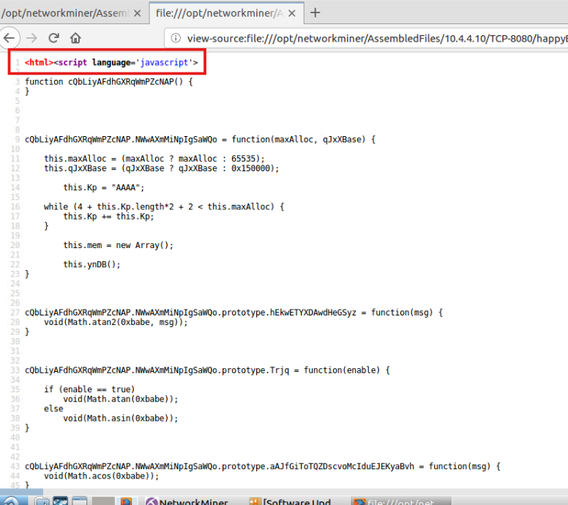
b. What is the password for Admin? 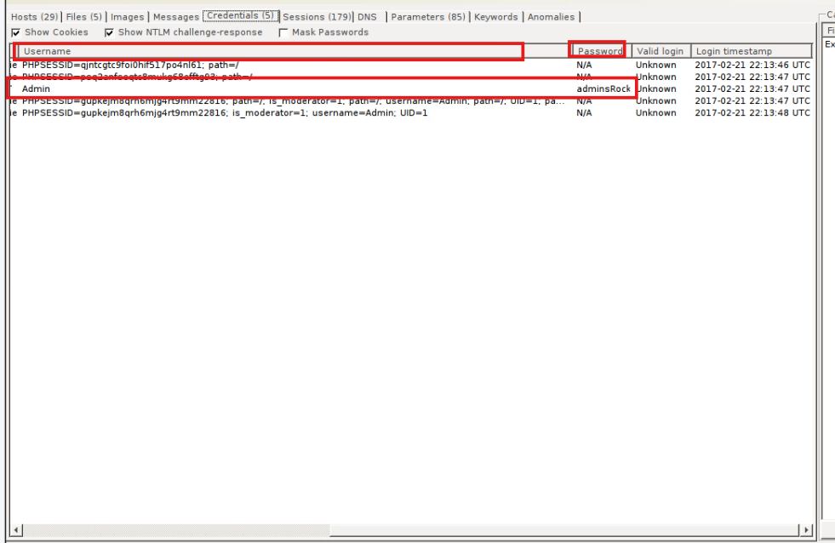
c. View the Parameters tab. As you review the list of parameter values what items would

require further review?

Parameter nədir?
Parameter → veb səhifəyə və ya serverə göndərilən əlavə məlumat / dəyişən deməkdir.
HTTP sorğularında (formlar, URL, POST data) göndərilən bütün məlumatlar parameter sayılır.
POST /login.php HTTP/1.1
Username=Admin&Password=adminRocks

3. Now open the ExploitDemo.pcap in Wireshark. Look at the HTTP requests. Select Statistics → HTTP → Requests. Do you see any suspicious requests? Yes

4. Select String from the list currently showing “Display filter.” The other selection lists will now be active. Select “Packet bytes” from the list displaying “Packet list.” Enter happyExploit in the small search field after “String” and click the Find button. Now right-click on the highlighted packet and select Follow -> TCP Stream.
NOTE: The highlighted packet will be a light gray with the default color scheme. What do you see in the stream?
